How to Reduce Your Solving Time
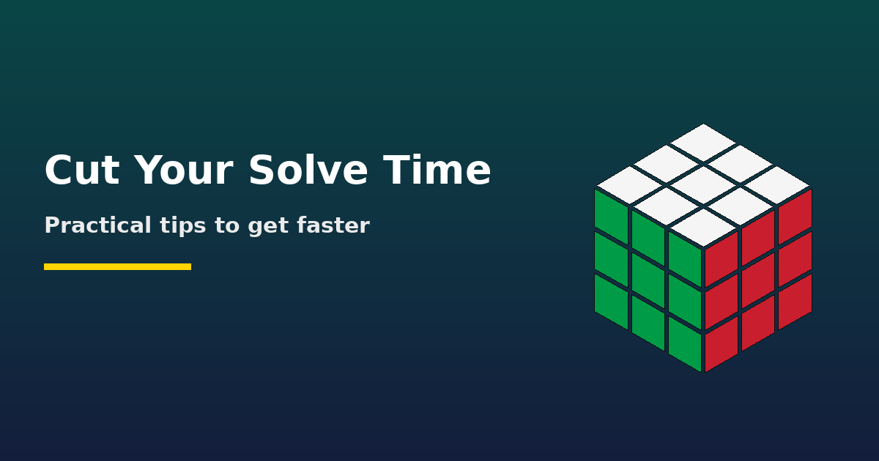
Getting faster at cubing is rarely about turning your fingers harder. The biggest time savings come from solving smarter. Here are the habits that give the best return on practice time.

1. Slow Down to Speed Up
Try solving at a pace where you never pause. Smooth, steady turning with no hesitations is usually faster than frantic bursts followed by stops. Pauses are where most time is lost.

2. Build Lookahead
Lookahead means finding your next pair, block, or algorithm while you are still executing the current one. It is the single biggest skill separating average and fast solvers.
- Practice slow solves where your eyes stay one step ahead of your hands.
- Try to find the next F2L pair (or block) before you finish inserting the current one.
- Keep your cube turning at a steady rhythm, even if it feels slow at first.

3. Use Inspection Properly
The 15-second inspection is free thinking time. Use it to plan more than the first step.
- Beginners: plan the entire cross.
- Intermediates: plan the cross and try to spot the first one or two F2L pairs.
- Advanced: plan an efficient cross and think about your first pair placement.

4. Improve Efficiency
Fewer moves means less time, as long as the moves are comfortable. Review your solves and look for places where you wasted turns, such as an inefficient cross or awkward pair insertions.

5. Learn Algorithms, Then Drill Them
Learning an algorithm and being able to execute it fast are separate skills. After memorizing, drill the algorithm until your fingers do it automatically.
- Practice your weakest cases more often than the ones you already know.
- Aim for fast recognition, not just fast execution. Recognition delays cause many pauses.

6. Set Up Your Cube
- Lubricate and tension the cube so it turns smoothly without popping.
- Choose a cube that fits your hands and your turning style.
- Clean the cube occasionally to keep it consistent.

7. Practice with Purpose
- Timed solves: Do real timed solves to track progress, but do not do only that.
- Slow solves: Train lookahead and efficiency without time pressure.
- Drills: Spend time on specific weaknesses, such as cross, F2L, or a few troublesome algorithms.
- Review: Watch a few of your solves back to catch pauses and errors.

8. Track Progress
Use a timer app that records averages, such as Ao5 and Ao12. Averages tell you much more about your real ability than a single lucky solve.

9. Look After Yourself
Short, focused sessions beat long exhausting ones. Take breaks, stretch your hands and wrists, and stop if you feel pain.
Pro tip: Pick one weakness per week, such as cross efficiency, pair recognition, or a hard PLL, and focus on only that. Targeted practice beats random solving.

